**IBM ASSIGNMENT – 2**

Python Programming

|  |  |
| --- | --- |
| Assignment Date | 23 September 2022 |
| Student Name | Swetha R |
| Student Roll Number | 710019106047 |

**Build a python code, Assume u get temperature and humidity values (generated with random function to a variable) and write a condition to continuously detect alarm in case of high temperature.**

import random

def temperature():

t=random.randint(25,100)

if t>30:

print(t,'High temperature detected');

print( 'Buzzer on, alarm sound is high')

elif t==30:

print (t,'Temperature reached maximum')

else:

print(t,'Temperature is good')

def humidity():

h=random.randint(25,100)

if h>65:

print(h,'High humidity detected');

print( 'Buzzer on, alarm sound is high')

elif h==30:

print (h,'Humidity reached maximum')

else:

print(h,'Humidity is good')

temperature()

humidity()

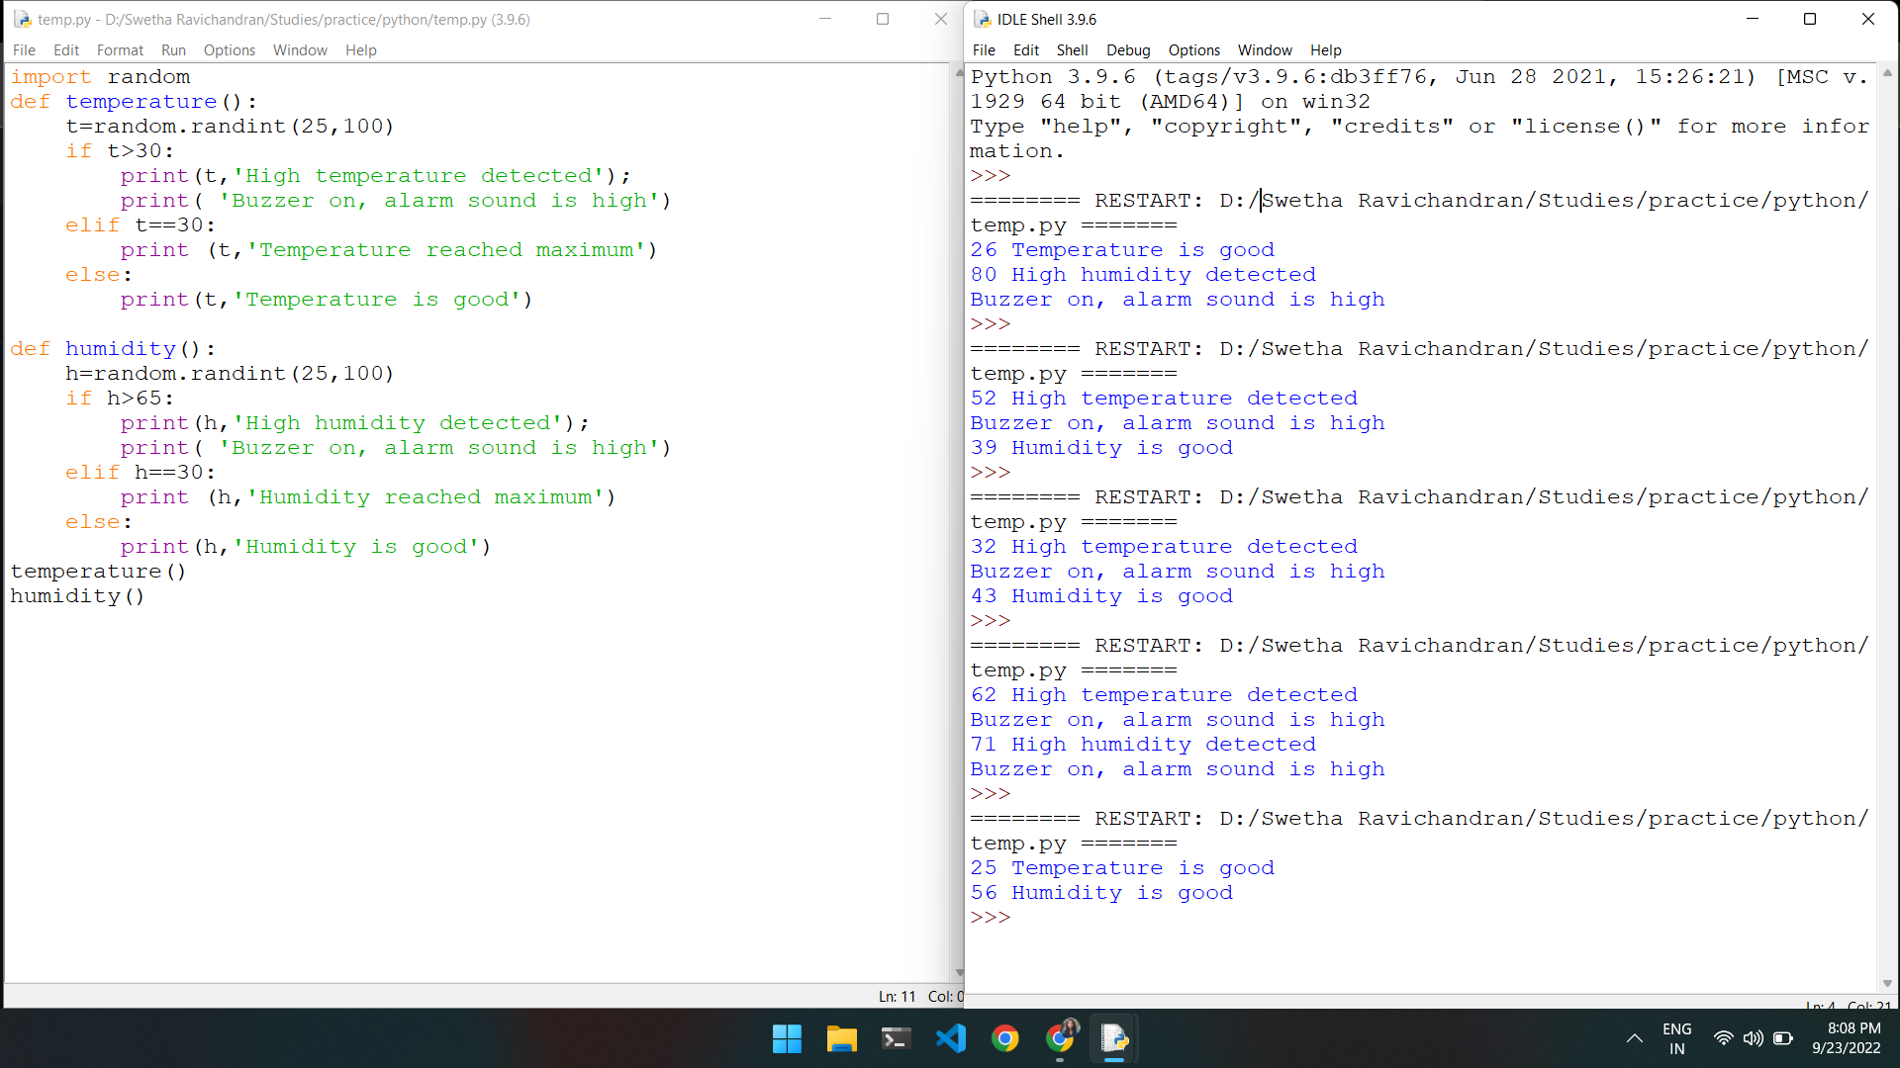**OUTPUT**